Zach Wilson

Wireless Motor Driver Project

**Description:**

My project is a motor controller that attaches to a samw25 Explained board for guidance. It will drive four motors, using two Texas Instrument DRV8885 motor drivers. These drivers are able to drive two outputs each, and output 1.5A. They have a resolution of 1/16 for each step. They are Bipolar, which means they are easier to program. The board will have a button on it for testing, and for engaging and disengaging whatever it is controlling. The goal is to make a turret with the board that can be controlled wirelessly over the internet.

This will be purely a motor driver for this application, I will not be adding any other sensors for automation. Something like that would be added in the future if I get the motors to work in the first place.

**Block Diagram:**

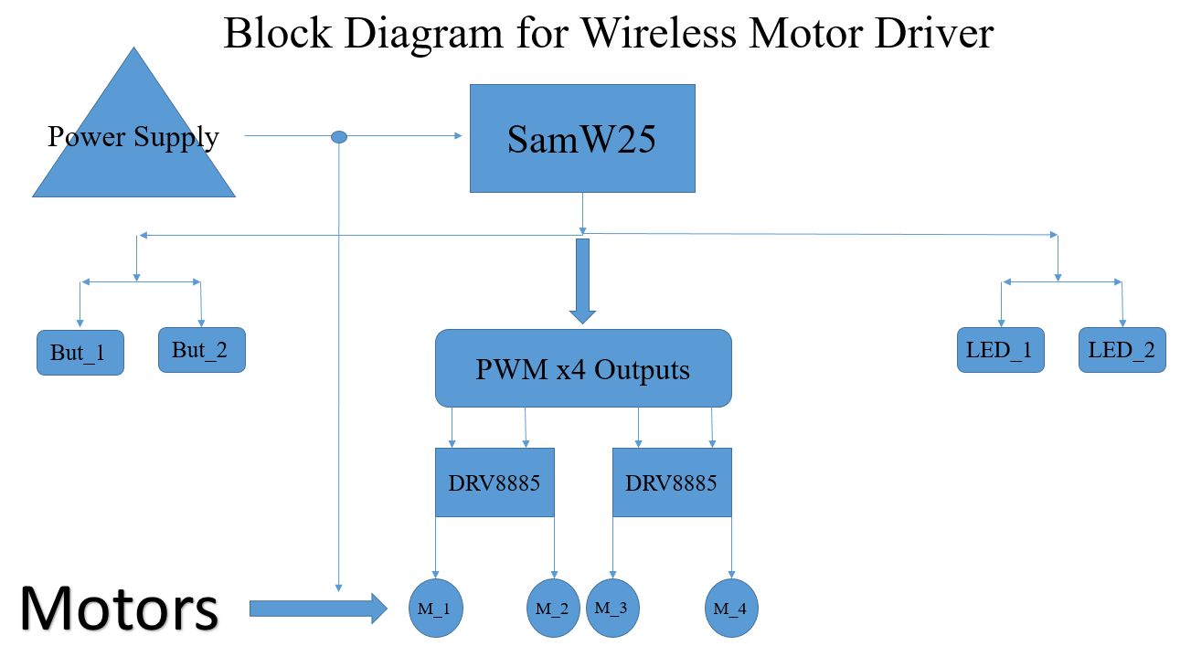

**Block Diagram Explanation:**

The Power supply supplies the SamW25 board itself, as well as the power for the motors. The two buttons and LED’s are hooked up to I/0 pins from the board, as well as 4 PWM outputs. The pwm outputs are inputted into the DRV8885 motor drivers, which have two outputs each to the motors.

**I/O Pins on the board:**

There will be two LEDs that will signal power, and whether the motors are engaged or not. There will be one button to engage or disengage the motors. There will be four PWM lines for driving the motors.

**Self-Contained Software Processes:**

The self-contained software is in the controlling board, not the motor driver board. This will consist of code to drive the four pwm pins for the motors, and reading incoming commands from a wireless user. This also includes sending info such as led states, motor statuses, and whether motors are engaged or not.

**Software Calls:**

Gets:

* Read status on if engaged or not
* Motor status (if on)
* See if motor has finished previous command
* Led States

Puts:

* Turn motors left
* Turn motors right
* Manually engage motors
* Blink led